Spiritual Guidance and Education
Monthly Newsletter - DEC '20
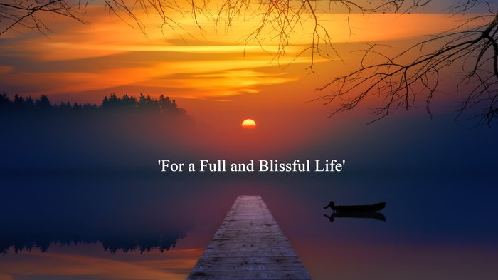

Well, there is no let-up within the author world ... not with Social media, promo, marketing and Facebook webinars on various aspects to attend to, and that’s not including updating blog posts and prep for this newsletter! Then, throw in some right computer hassles and a couple of local power cuts and you soon realize how much you depend upon things working – included the wi-fi /internet!
I guess it's difficult for us not to get frustrated sometimes at such earthly niggles and challenges, but if there was any more would definitely have to count to 10 more than once, and that would have meant taking my shoes and socks off – LOL! I reckon we should all revert to using 2 tin cans and a million miles of string!
In last month’s newsletter, I had mentioned that A Pocket Full of God: Transform the Nature of Your Life was submitted to the October 2020 'Virtual Frankfurt Book Fair' - (non-attendees’ version because of COVID-19) ... well, a publisher in India has recently requested further info from me which is fab news. It would be absolutely amazing to get a foreign rights deal, but obviously, there are no guarantees in this game!

------------------------------------------------------------------------------------------------------

The UK is still in National lockdown until tomorrow the 2nd Dec, but depending on where you live, we then go straight into tiers 1, 2 or 3 with continued restrictions. Many people are suffering financially, physically, emotionally, and mentally. So, I really hope the 5 days relaxation of these rules over the Christmas period will bring real welcome relief to all four nations across the UK.
In amongst all this, Caroline and I managed to go walking for several miles over the countryside. It's the first time we'd been out together for many months - away from the house, work, lockdown, the laptop etc! We were so lucky as it was the most beautiful winter's day ... the warm sun shone like a beacon across the blue sky (which makes a change from rain) - and over the fields and valleys as we passed by Drayton, Bringhurst and Neville Holt.
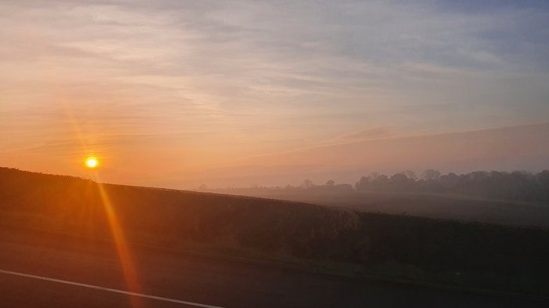

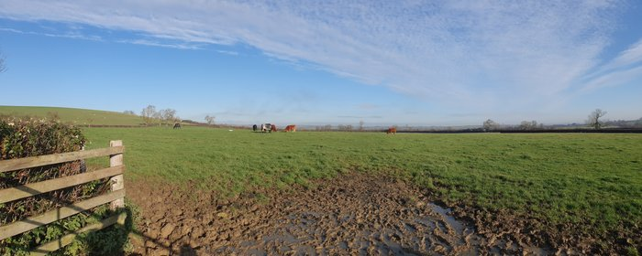
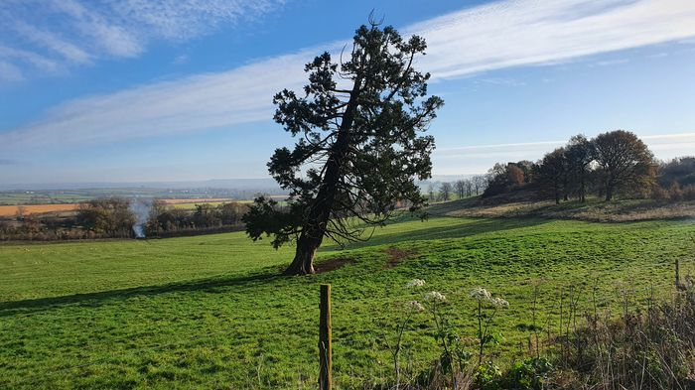
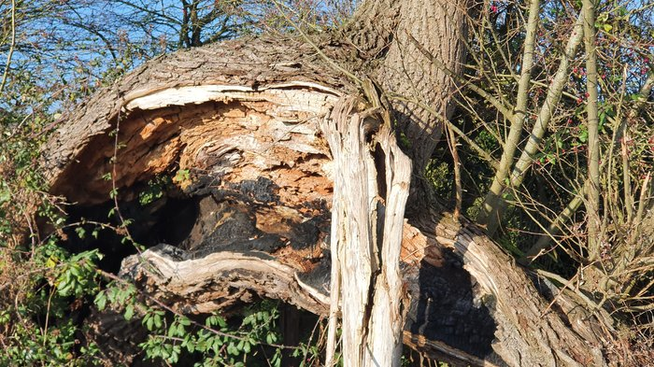
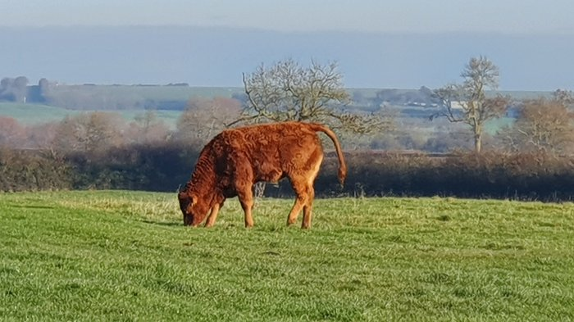
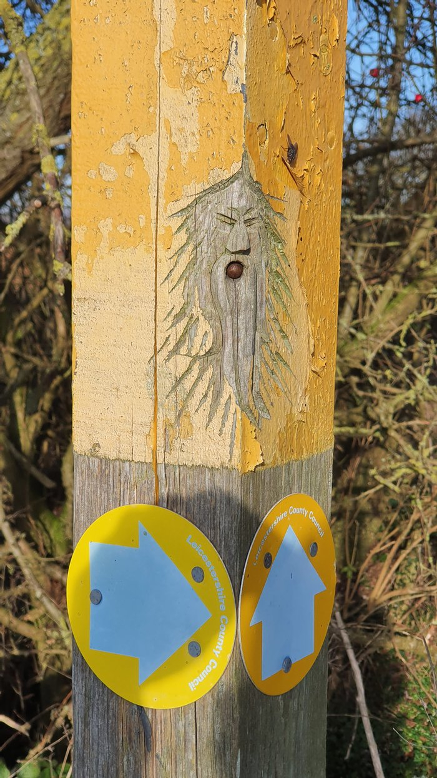
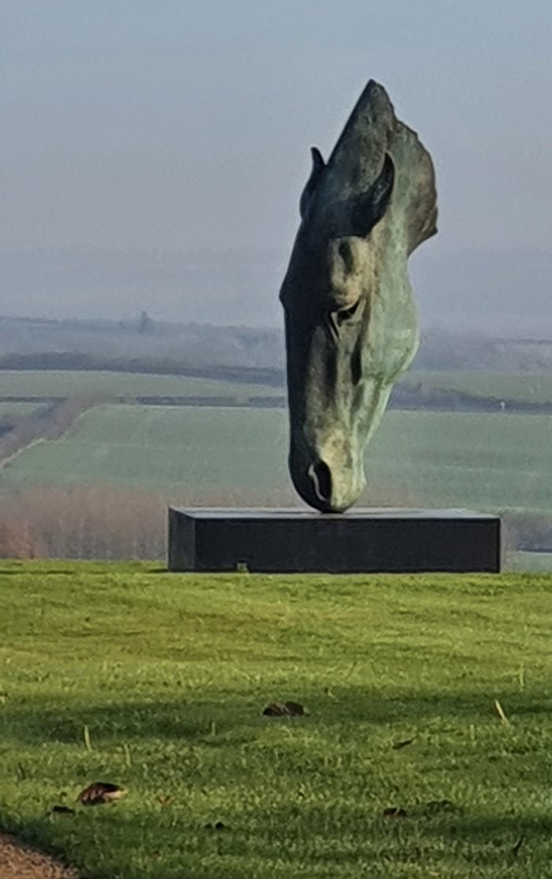

----------------------------------------------------------------------------------------------------------------
On the work front (painting and decorating) - I had the privilege to work on a late Edwardian front door, it must have had about 10 layers of paint on it!

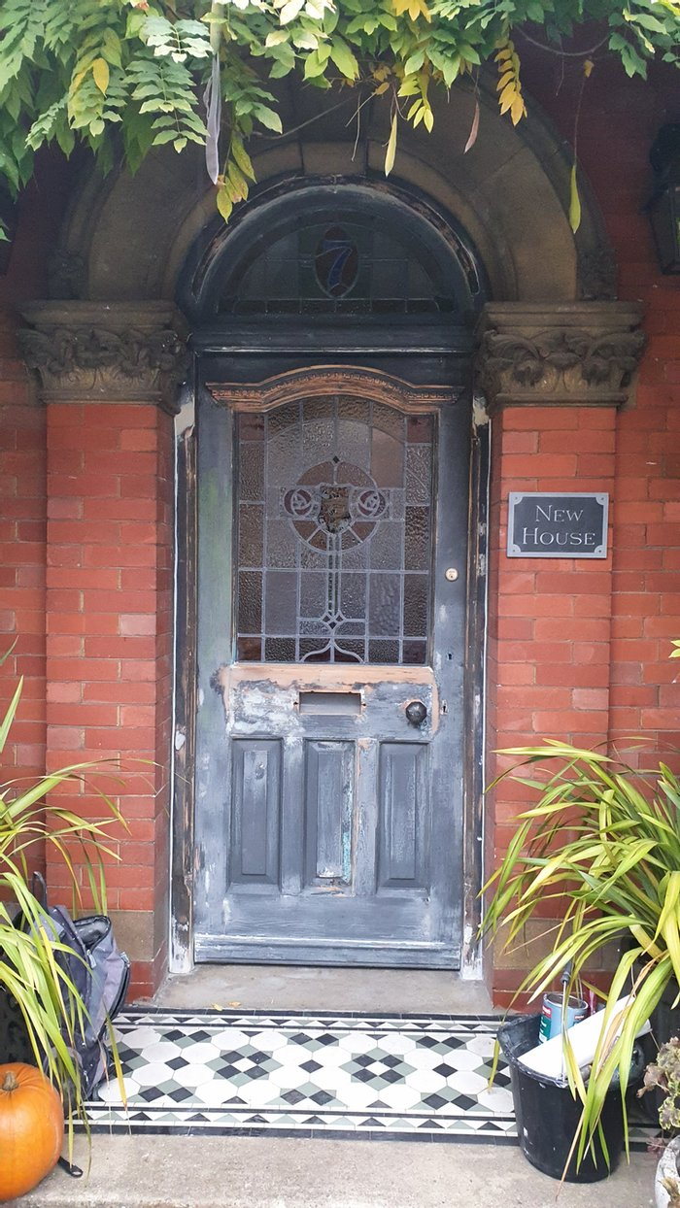
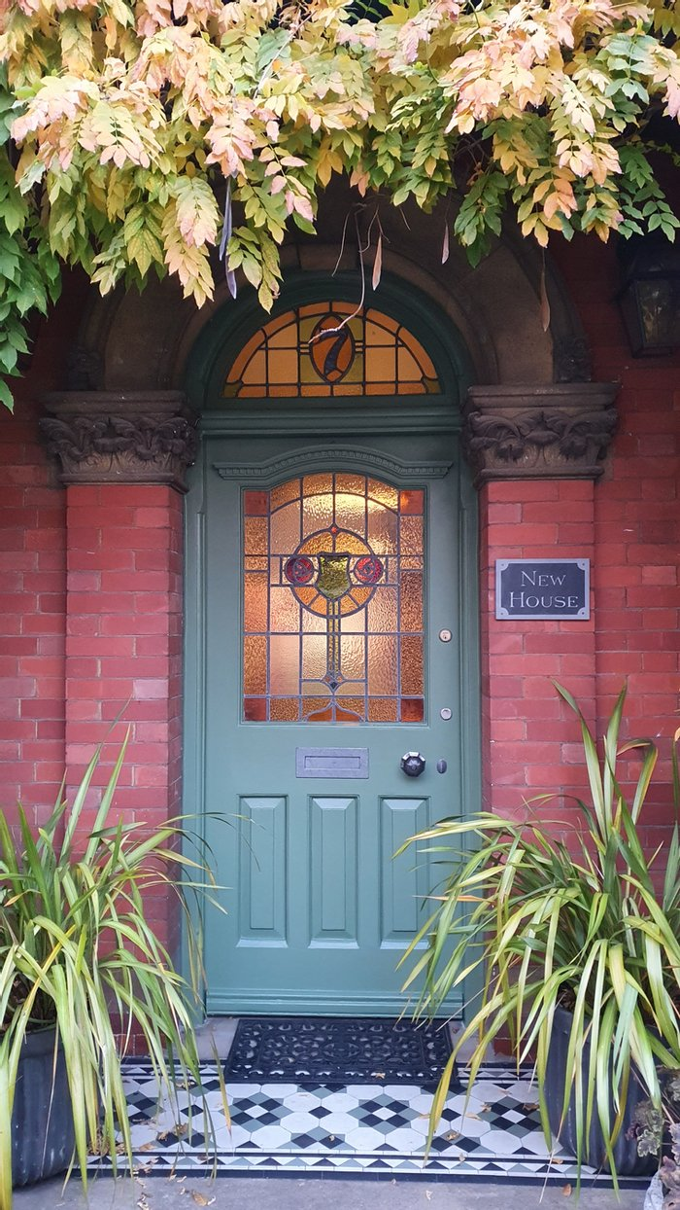
------------------------------------------------------------------------------------------------------

Nurture your own true Nature.

"You need to be adaptable and intuitive and go with the flow of your own feelings and thoughts. I do not refer to selfish traits, but hope you become inspired to do everything in the name of truth. Try to speak and act with the foresight and action of true human values; you could say, be selfless.

Only when you let go of the past and learn to forgive yourself and others; can you then develop and appreciate the love you are and always will be. So, be kind to yourself, for this kindness will be communicated towards all beings and, in turn, be reflected towards you. If you wish to enjoy, simply end your search for earthly joy ... in other words, end-joy.

When you contemplate upon Creation, which is both beautiful and powerful, you will understand that the elements of earth, air, water, and fire magnify the glory of life and death, and are affected by the energy which transmutes from every heart and mind upon the impermanent plane.

Think of thunder and lightning; the brilliant flashes piercing the sky and the mighty rumbles, or earthquakes; tremors which shake the ground thousands of miles away. How great is the awe that humans feel in the presence of such mighty, natural power? And yet, love is mightier than all of these forces combined, for our hearts are ONE.

It is therefore essential that you strive to live in peace and harmony, for all forms of life are ‘one’ too. Everyone must appreciate and show gratitude for Mother-Earth who sustains your physical embodiment. By living in conjunction with Nature, and recognising our ‘oneness’, you realise that every action you take leads to a positive or negative consequence.

As such, balance is the key to stability. And, in being ‘still’, you can nurture your own true nature within. You will realise that to receive the information and knowledge that you require on your 'journey', you must first turn inwards. This is the only way, for when you connect with me in your heart, the truth becomes known to you. Only by believing you are a spark of Divinity; can you understand the answers inside you. Amen."

Remember ... real peace reigns, not in the time between wars, but in the ‘letting go’ of everything you ‘think’ you are.
------------------------------------------------
PS. If you have any burning questions on your own spiritual development or are concerned about any aspect of your earth-plane journey, let me know. Try to keep positive and joyful, especially in these trying times. May your Christmas be merry and bright and as loving and peaceful as can be ... and we'll catch up at the start of January!
PPS: Please could you share this newsletter on any of your social media feeds ... it just might help another person when they need it most - thank you in advance! Dave (AFY)

Get in Touch: ascensionforyou@btinternet.com

