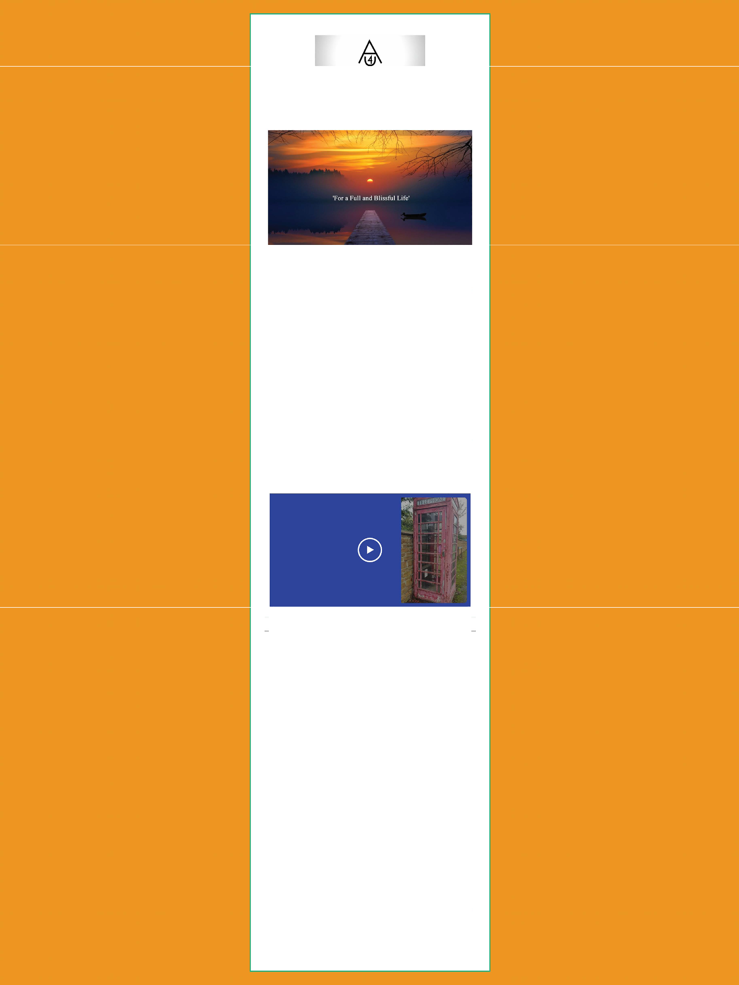ASCENSION FOR YOU • BOOKS BY DAVID KNIGHT

Spiritual Guidance and Education
Monthly Newsletter – DEC ‘20

What I have been up to!
On the book front it's been manic to say the least. What with the launch of the latest release ... A Pocket Full of God: Transform the Nature of Your Life in Audiobook/E-Book and paperback formats as well as getting the new website up and running, it's been a pretty hectic time with not much sleep. Some wonderful book reviews have started to come in via Goodreads, Net Galley and Amazon. On top of that, the book was submitted to the October 2020 'Virtual Frankfurt Book Fair' - (non-attendees’ version because of COVID-19 -19) ... so we'll wait to see how that goes.

BT\11/, the cats now think I’ve only adopted them, and my long suffering ... yet amazing wife, thinks I have a new 'love' in my life – ‘cos' I might as well be married to the computer" - yikes!

Anyway, Strictly Come Dancing has recently started so Christmas is not that far away - time for a little break - fingers crossed! Let us hope the 'Rule of 6' disappears for the festivities across the UK (and of course around the world), so that everyone's family and friends can finally celebrate and be together.

On the work front (painting and decorating) - one of my jobs after full lockdown was this zombie looking GPO telephone box. Gee whizz ... this was some effort. If you can tell the difference perhaps you can let me know. Here's a little video...

Divinity, and Your one true Heart.

"True peace comes to those who do not desire anyone or anything. Those that dilute and dissolve their ego find inner peace more quickly, and subsequently find their higher self. This brings illumination and recognition of their own Divinity and me. Once you recognize this, understanding new knowledge becomes easier, fife is more fulfilling, and you can blossom into the Soul you str ive to be.

Realize by living in truth, you cannot fear. If you dispel tear, you will know I am near. When you recognize I am near, you will hear my internal voice. Then, when you hear me, knowledge and wisdom enable you to find your true reality, a living flame born from a spark, which glows eternal and shines mercifully from our 'one' true heart. Amen."

PS. Remember, Peace and Joy are the cornerstones for Love to f low from, through and to your heart.

PPS. If you have any burning questions on your own spiritual development, fire them over. In the meantime, try to keep strong and positive in all you do. Peace and joy and love to you and your family, and we will catch up at the start of Dec!

Get in Touch: ascensionforyou@btinternet.com
Share Via: I Check out my website/ free book e Join me on the Wix maonbdilkeeaepppintotosutacyh. updated, share posts
1:1 Download & Join

